Actual vs Predicted Sales (line chart).
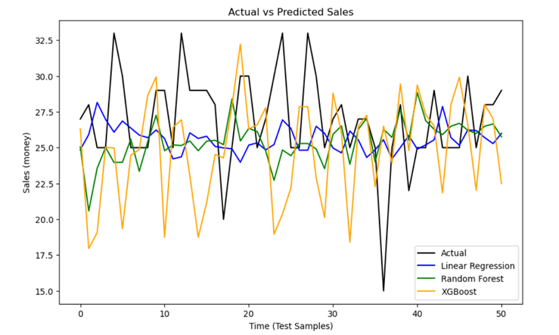
Figure 1: Actual vs Predicted Sales for all models.

Residuals Distribution Across Models
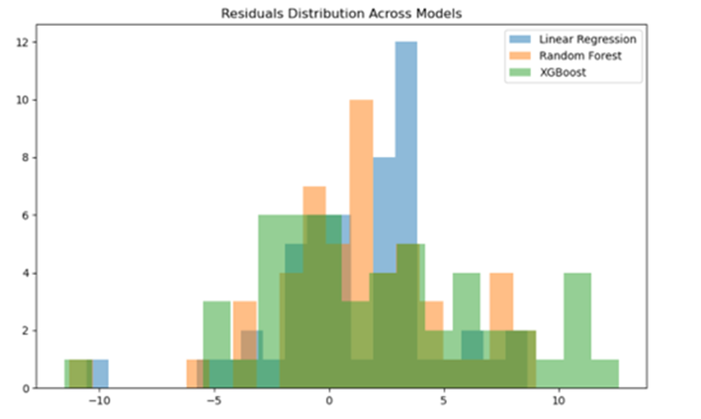
Figure 2: Residuals distribution showing robustness of predictions.

Training Time Comparison (bar chart).
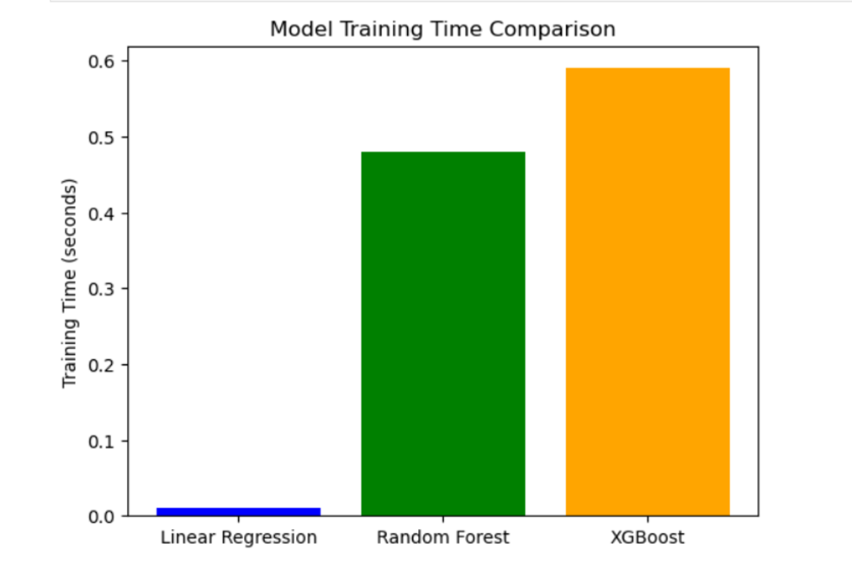
Figure 3: Training time comparison across models.

